2.1

1. Study penguins - X
2. Get up early -
3. Have breakfast
4. Get out in a boat
5. Visit different islands
6. Take photos
7. Have dinner
8. Work in the lab
9. Write emails
10. Go to bed late
11. Relax
12. Read a book

2, 4, 7, 11

3 2.1 Listen again.

1. In the summer my days are long. I GET UP early and HAVE BREAKFAST.

S + V1 (s, es)

S = Subject > He she it  
  
V1 = Fe’l

I work

We learn

You study

They read

He/She/It works

(bu holatda felga s yoki es qo’shiladi

I, we, you, they > Don’t + do

He,She,It > Doesn’t/ Does not + do

Do + I, we, you, they + do?

Does + he/she/it + learn play?

He has

He/she/it Agar fel ch, ss, s, x, z bilan tugasa (es qo’shiladi)

Har doim ravish to be dan keyin va V dan oldin keladi

To be = am is are

S + always/Never + Verb

I always, come on time

S + amlislare/Don’t/Can’t

2.3

1. S
2. Iz
3. S
4. Z
5. During the week he ALWAYS gets up early and he usually arrives at a volcano at seven o’cklock (always/ usually)
6. His work sometimes be dangerous and he never go alone > be – is / works
7. He usually returns to the research center at about 1 ocklock. And he always have launch in the lab > have – has
8. On Friday and Saturday nights he usually relax at home. He hardly ever go out with friends and he often go to bed early > relaxes, goes, goes

Wake up – uyqudan uy’gonmoq

Get up – uhlayotgan o’rnidan turmoq

Stand up - turmoq

Go home > go TO home bo’lmaydi

Go to bed > uxlamoq

Go to work/university > go to the bo’lishi mumkin farqi uyerga borib o’qisa the qo’shilmaydi, the qo’shilsa maqsad o’qish bo’lmasa

Have a shower

HOME WORK

2.1 not bookdan

2.2 ni yarimi

10.10.2024

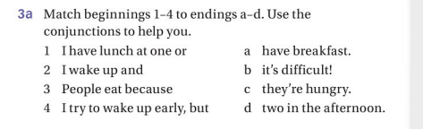

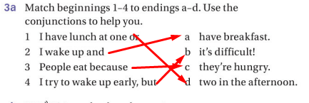

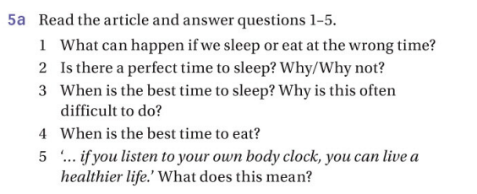

1. We will tired and hungry during the day.
2. No, because everyone’s body clock is different.
3. As Micheal Howell says the best time to sleep is six hours at night and two hours in the afternoon. Difficult? Because most people at work in that best time.
4. Best time to eat is two hours after you wake up and three hours before you go sleep.
5. Perhabs the most important thing to remember is that

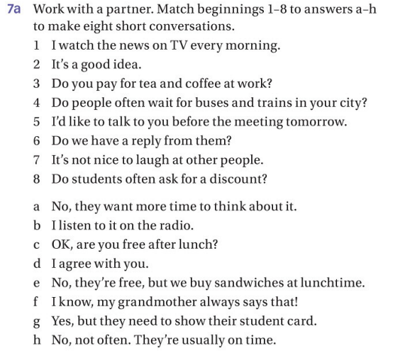

1. B
2. D
3. E
4. H
5. C
6. A
7. F
8. G

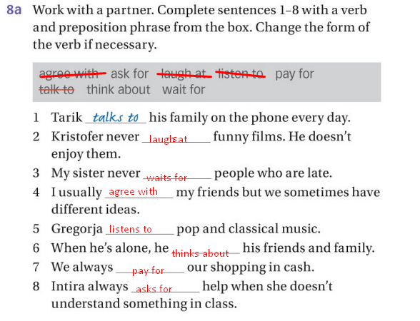

HOME WORK

2.2

2.3

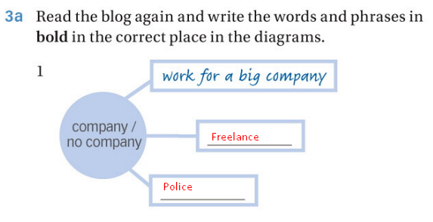

Home work

3.1

1. mechanic.

2. cleaner.

3. An airplane pilot.

4 A photographer.

5 A Student.

6 A musician .

7 A chef or cook.

8 A businessman (or office worker).

9 A musician playing a traditional instrument (could be specific to culture, like a lute player).

10 A doctor.

11 A dentist or dental hygienist

3.2

3.3 half

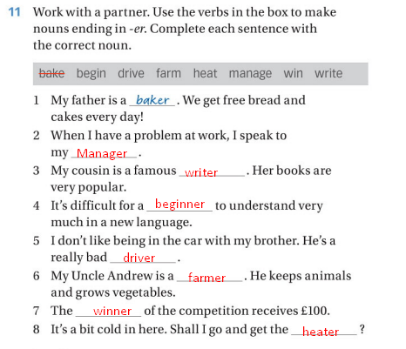

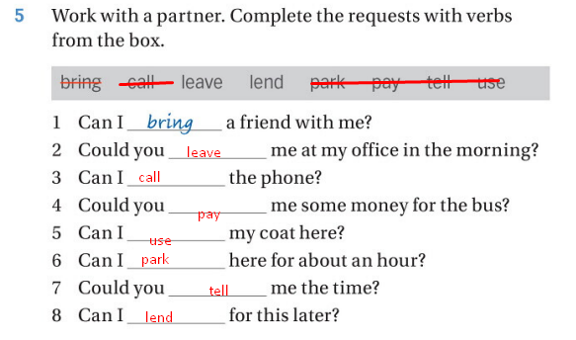

18 – oktyabr 2024

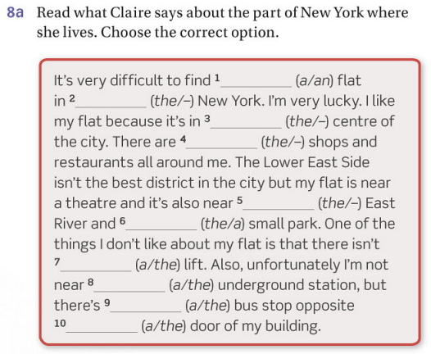

1. A flat
2. – new york
3. The centre
4. – shops
5. The East River
6. A small park
7. A lift
8. The underground
9. A bus
10. The door of my building

Home work 4.1, 4.2.

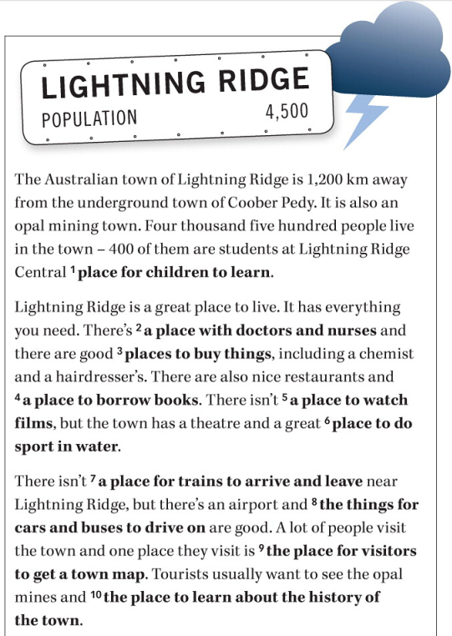

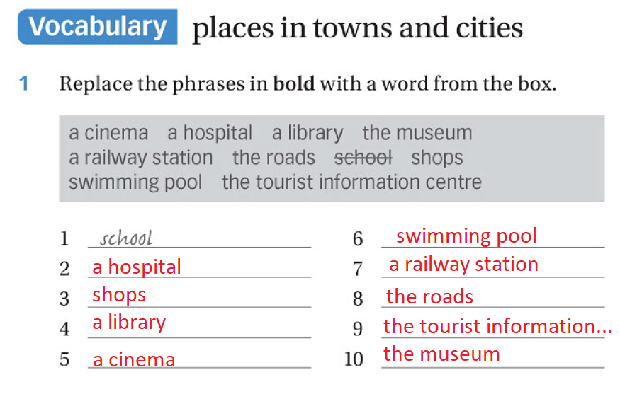

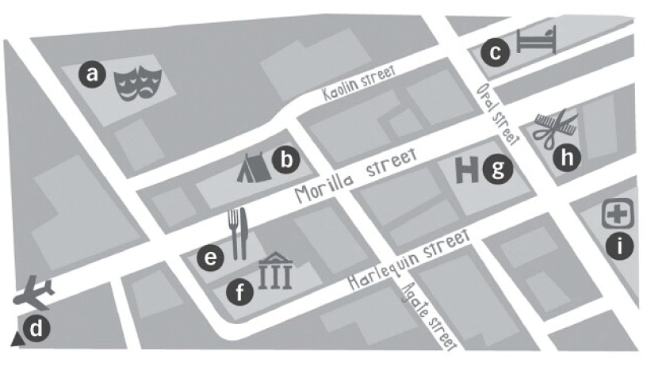

1. Theatre
2. Tent
3. Hotel
4. Airplane
5. Restaurant
6. Museum
7. Hospital
8. Haiddresser
9. Medicine

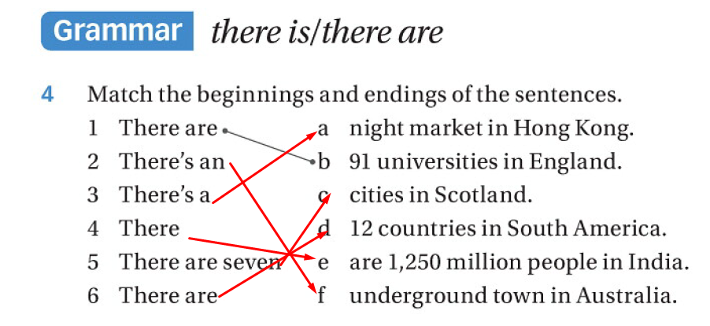

Listening

1. Carefully
2. Dangerously
3. Quitly
4. Late
5. Clearly
6. Correctly
7. well

3a

1. E - True
2. I – False F
3. F – False H
4. A - True
5. B - True
6. C - True
7. H – False I
8. G - True
9. D – True

Homework

part 1 questions topic 3

workbook 5.3 and 5.4

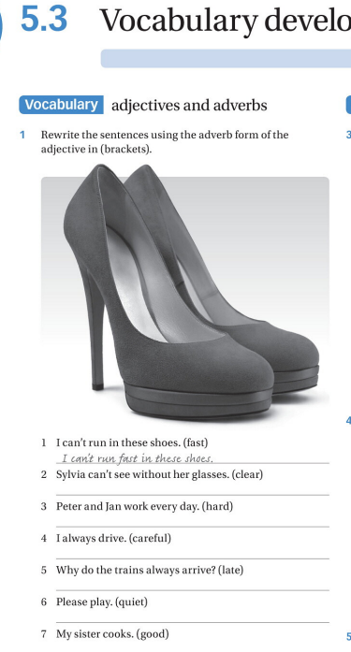

2. Sylvia can’t see clearly without her glasses

3. Peter and Jan work hard every day.

4. I always drive carefully.

5. Please play quietly

1. Why do the trains always arrive lately.
2. My sister cooks well.

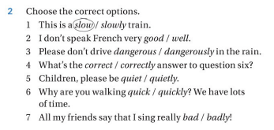

* + - 1. Slow
      2. Well
      3. Dangerously
      4. Correctly
      5. Quiet
      6. Quickly
      7. Bad

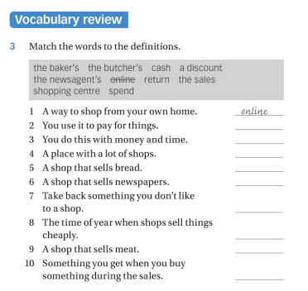

A way to shop from your own home – online

You use it to pay for things – cash

You do this with money and time – spend

A place with a lot of shops – shopping centre

A shop that sells bread – the baker's

A shop that sells newspapers – the newsagent’s

Take back something you don’t like to a shop – return

The time of year when shops sell things cheaply – the sales

A shop that sells meat – the butcher’s

Something you get when you buy something during the sales – a discount

|  |  |
| --- | --- |
| Clothes | Accessories |
| coat | glasses |
| dress | gloves |
| hat | jewellery |
| hoodie | tie |
| jacket | umbrella |
| jeans |  |
| scarf |  |
| shoes |  |
| skirt |  |
| socks |  |
| suit |  |
| T-shirt |  |
| top |  |
| trainers |  |
| trousers |  |

30. 10 . 2024

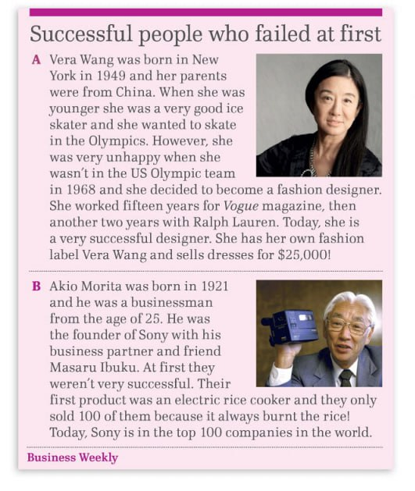

|  |  |  |
| --- | --- | --- |
|  | Vera Wang | Akio Morita |
| Born (when?) | She was born in 1949 |  |
| Early career | She was a very good Ice skater |  |
| Problems | Shes problem were unhappy, because of she wasn’t in the US Olympic team |  |
| Famous for… (what?) | She became designer, she worked fifteen years for Vogue magazine, then another two years with Ralph Lauren. |  |

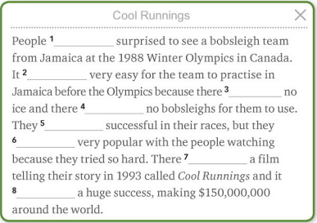

1. Was T
2. Was F (Was not)
3. Was T
4. Were T
5. Were not T
6. Were T
7. Was T
8. was T

6.1

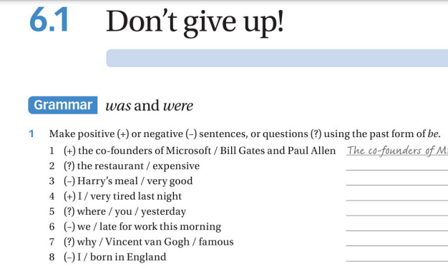

1. was the restaurant an expensive?
2. Harry’s meal wasn’t very good
3. I was very tired last night
4. Where was you at yesterday
5. We were not late for work this morning
6. Why Vincent van Gogh was famous?
7. I was not born in England

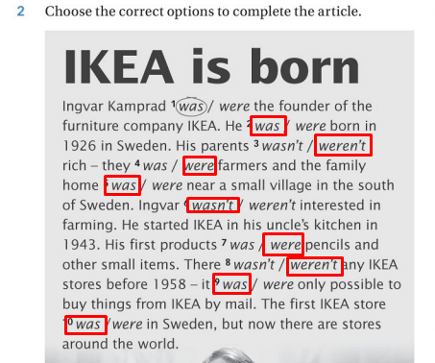

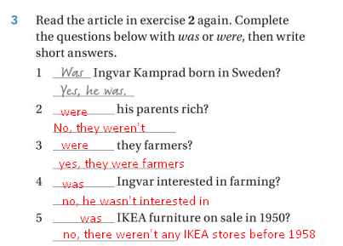

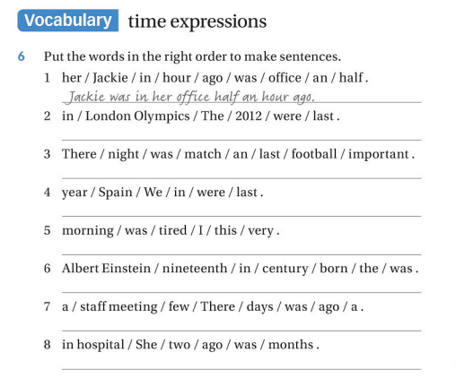

1. Jackie was in her office half an hour ago
2. The London Olympics were in 2012 last
3. There football match was an important last night
4. We in span were last year
5. I was tired in this morning
6. Albert einstein was born in the century nineteenth
7. There a staff meeting was a few days ago
8. She was in hospital two months ago

+5

Ok

I don’t think it’s fashionable

6.2

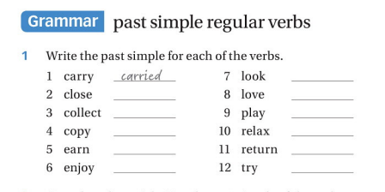

1. Carried
2. Closed
3. Collected
4. Copyed
5. Earned
6. Enjoyed
7. Looked
8. Loved
9. Played
10. Relaxed
11. Returned
12. Tried

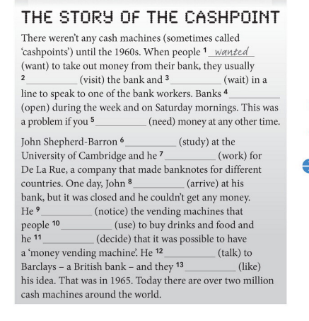

1. Wanted
2. Visited
3. Waited
4. Opened
5. Needed
6. Studied
7. Worked
8. Arrived
9. Noticed
10. Used
11. Decided
12. Talked
13. Liked

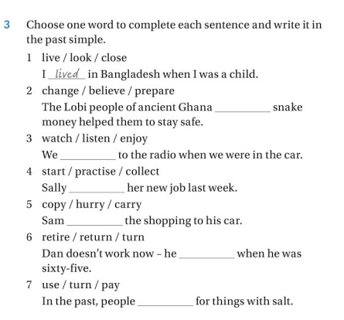

1. Lived
2. Prepared
3. Listened
4. Started
5. Carried
6. Retired
7. Used

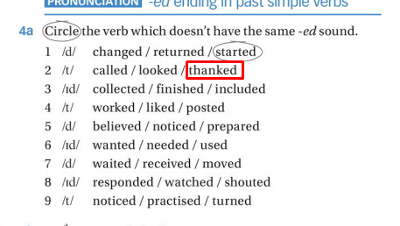

I don’t understand

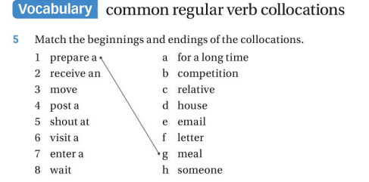



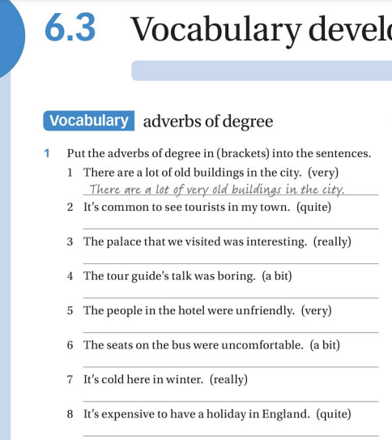

1. Done!
2. It’s common quite to see…
3. The palace that we visited was really interesting
4. The tour gude’s talk was a bit boring
5. The people in the hotel were very unfriendly
6. … were a bit uncomfortable
7. It’s really cold in winter
8. It’s quite expensive to have holiday in England

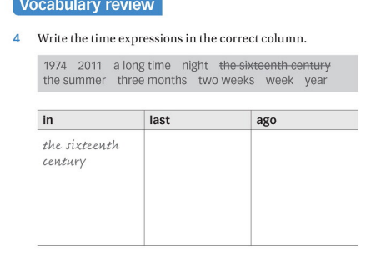

|  |  |  |
| --- | --- | --- |
| in | last | ago |
| The sixteenth | night | A long time |
| century | week | Three months |
| 1974 | year | Two weeks |
| 2011 |  |  |
| The summer |  |  |

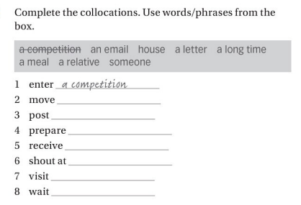

1. Done!
2. House
3. A letter
4. A meal
5. An email
6. Someone
7. A relative
8. A long time

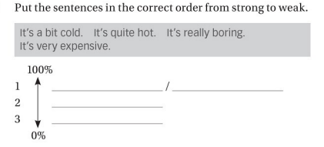

1. It’s very expensive / it’s really boring
2. It’s quite hot
3. It’s a bit cold
4. Died
5. Was
6. Decided
7. Loved F - love
8. Payed
9. Wanted
10. Was
11. Painted
12. Was F - is
13. Traveled F – travel

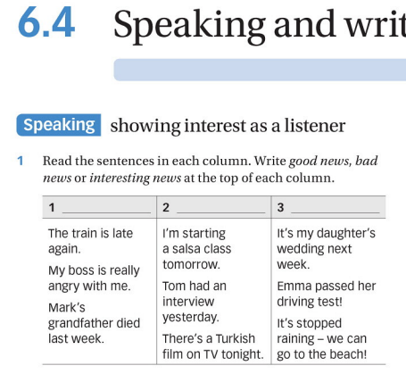

1. Bad news
2. Interesting news
3. Good news

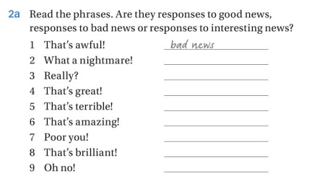

1. Done!
2. Bad news
3. Interesting news
4. Good news
5. Bad news
6. Good news
7. Bad news
8. Interesting news
9. Bad news

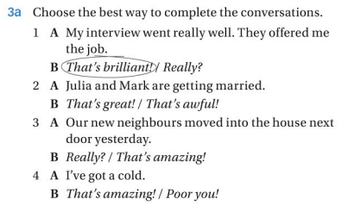

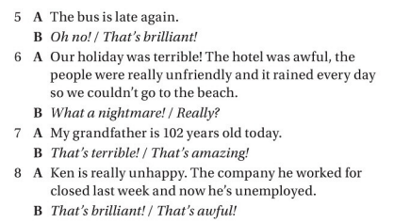

1. Done!
2. That’s great
3. Really?
4. Poor you!
5. Oh no
6. What a nightmare
7. That’s amazing
8. That’s awful

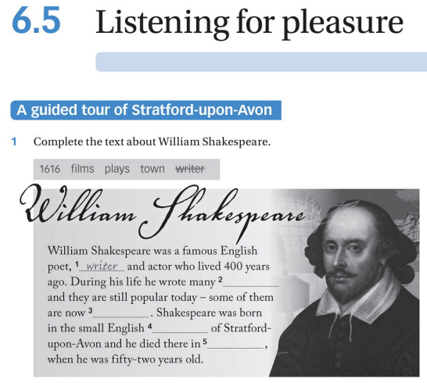

1. Done!
2. Films
3. Plays
4. Town
5. 1616

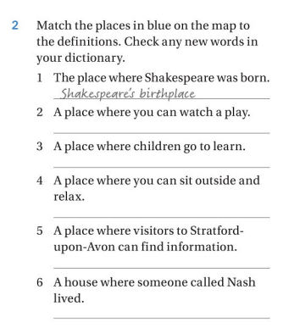

I don’t understand

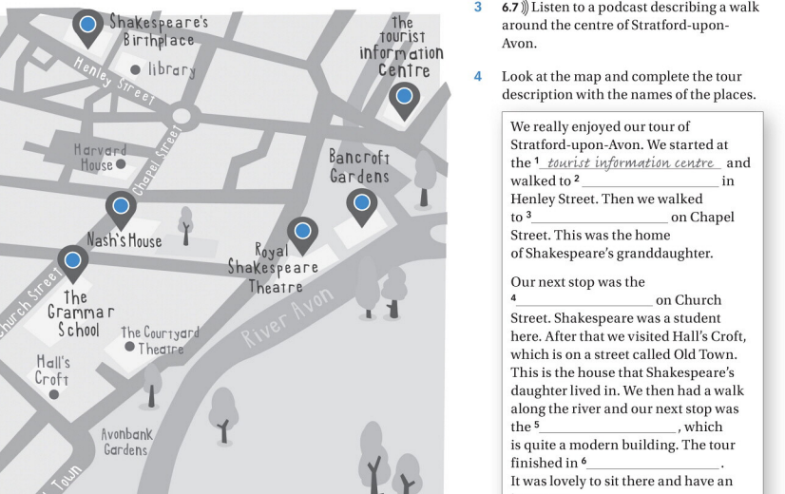

1. Done
2. Shakespeare’s
3. Nash’s home
4. The grammar school
5. Royal shakerpeare theatre
6. Bardencoft gardens

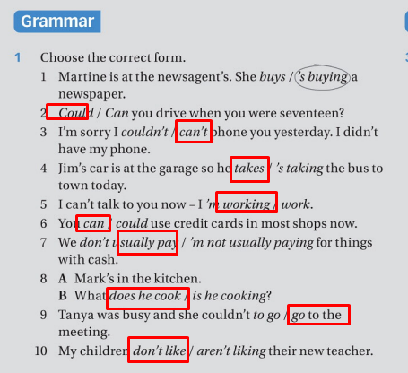

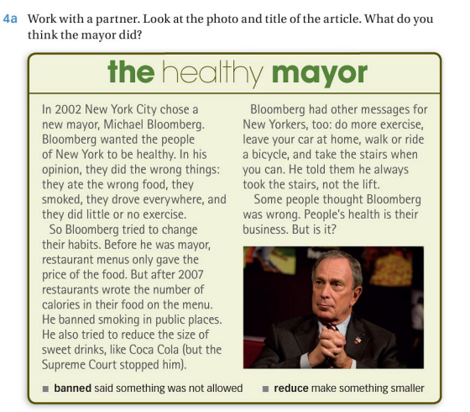

1. Ate the wrong food, smoked, drove everywhere, little or no exercise
2. Wrote the number of calories in their food on menu, he banned smoking
3. Tried to reduce the size of sweet drinks
4. Do more exercise

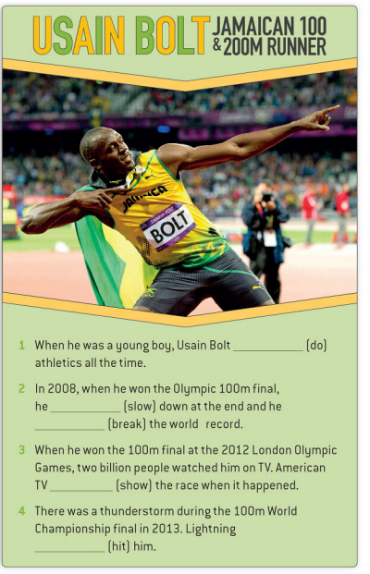

1. Did F (Didn’t do)
2. Slow F (slowed)
3. brouk
4. Showed
5. Didn’t
6. D
7. A
8. E
9. B
10. C

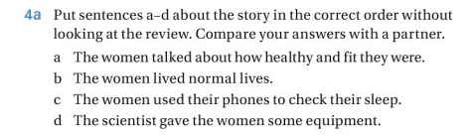

1. D
2. B
3. C
4. A

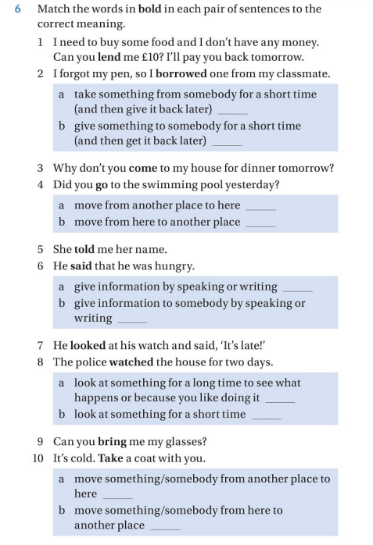

1. B
2. A
3. A
4. B
5. A F
6. B F
7. B
8. A
9. A
10. B

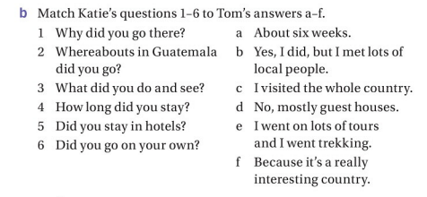

1. F
2. c
3. E
4. A
5. B F (D)
6. D F (B)

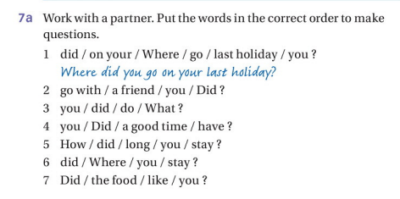

1. Done!
2. Did you go with a friend?
3. What did you do?
4. Did you have a good time?
5. How long did you stay?
6. Where did you stay?
7. Did you like the food?

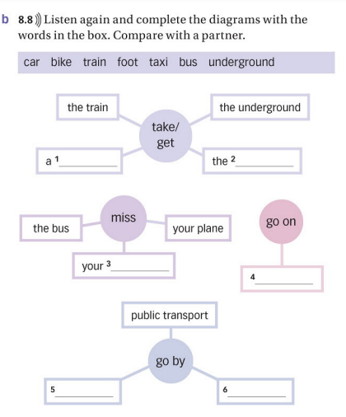

1. Car F
2. Bike F
3. Train
4. foot
5. underground F
6. bus F

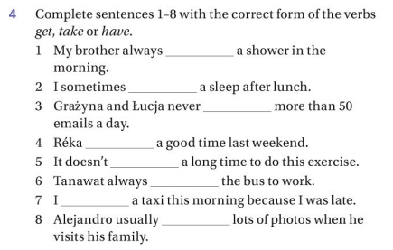

1. have F has/takes
2. get F have
3. get
4. had
5. took F take
6. take F takes/gets
7. got (took)
8. takes